Artificial Intelligence in the fight against COVID-19 pandemic

**Why do patients have to wait for long hours to get tested when artificial intelligence can do it in seconds? Let's** **understand how cutting-edge AI technology can help in curbing these pandemics.**

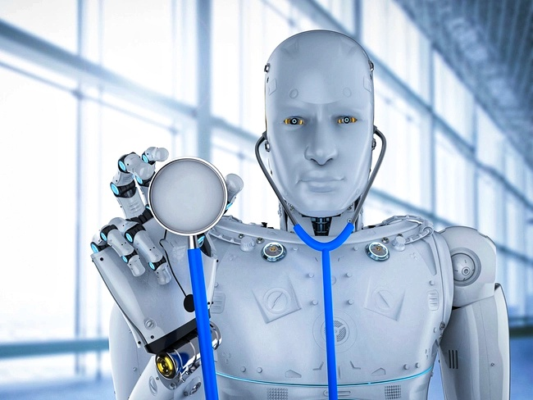

**Chatbots for COVID 1****9 screening**

Chatbots are no longer pre-programmed rule-based algorithms that provides stock answers. Machine learning (ML), natural language processing (NLP) and artificial intelligence (AI) capabilities are now transforming chatbots, embedding them with a certain degree of ‘intelligence’ to understand the user’s language and search intentions. Deep learning models of Python, such as Universal Sentence Encoders (USE), perform effective text vectorization by converting text into numerical representation so that texts can be understood both for context and semanticity. For example, let’s look at a scenario in which one user asks, “What are the symptoms of COVID-19?” another user types “Corona symptoms”, and a third user, “I have a running nose. Is it Corona?” Now, all three questions, though differently phrased but have the same meaning. USEs and NLPs understand these language variations and semanticity and can render direct answers relevant to the user’s search intent. Also, chatbots can perform automated preliminary health screenings by deploying forms on websites or mobile applications. Direct answers and test results can be rendered in a matter of seconds.

**Neural networks for monitoring progression**

Medical imaging like X-rays, CT scans, etc. have become fundamental to healthcare monitoring. Doctors analyse disease progression using radiology expert analysis and scan reports. Neural networks and the deep learning algorithms of AI can go a long way in accelerating the pace of the analysis and auto-generating the scan reports. Image-to-image neural networks use the new images (the input layer) with their internally trained disease data sets (hidden layer) to generate output images (output layer).

There are two benefits of adapting to neural networks-based disease monitoring. First, conventionally, scanning machines use high radiation exposure in patients to generate high quality or clear scanned images. High-quality scanned images came at the cost of a patient’s health. High radiation poses the risk of cancer and it has been considered an unavoidable side-effect for those who take scans. However, with image-to-image neural networks, it is now possible to let the patient, get scanned with minimum radiation exposure. The deep learning algorithms compare the input images with their internally trained mass classifier data sets, to auto reduce all data noise. Neural networks are trained to improve image resolutions, enhance image contrasts, and provide a more accurate analysis of the disease’s progression.

The second benefit is the quality of the prognosis and the accuracy of the results. Radiology experts no longer need to perform a detailed subjective analysis on every scan or testing sample that comes their way — a task that is time-intensive, repetitive, and costly. A neural network can do the same job with greater accuracy (up to 95 percent) in just a few seconds. With the ongoing COVID-19 pandemic, patients with respiratory illnesses like pneumonia wait to get themselves scanned and see the results.



**Machine learning for disease surveillance**

The success of the PMO’s Aarogya Sethu mobile application can be primarily attributed to the government’s interest in solving human problems using technology. During this COVID-19 pandemic, contact tracing and disease tracking was done using the Blue Light Energy (BLE) functionality of mobile devices. Comprehensive information on infected citizens, and all those who came in proximity with them, was sent to the central servers. Citizen alerts with options for preventive actions were sent to the users. COVID-19 fatalities are more prominent in the elderly population than in other age groups. Now, what if we had software that is able to infer such trends and also pre-populate a cadastral hotspot map, with all the contact and address details of the identified elders in a specified age group? Gaining insights into such trends can help the government take appropriate disaster mitigation steps in real-time.

Machine learning has the power to provide such robust insights. Not only can the deep learning algorithms predict trends, but they can also generate spatial maps and tabular reports of all vulnerable populations. These outputs can significantly help the government, epidemiologists, health care workers, and other stakeholders make informed decisions that can efficiently control the disease’s spread.